**Consider the below two tables**:

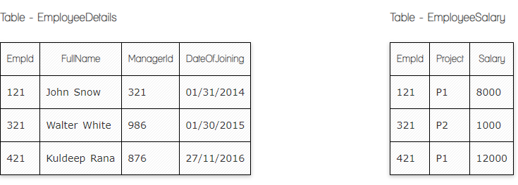

**Ques.1. Write a SQL query to fetch the count of employees working in project 'P1'.**

**Your Answer:**

SELECT COUNT (Empid), Project

FROM EmployeeSalary

GROUP BY Project

HAVING Project = ‘P1’;

**Ques.2. Write a SQL query to fetch employee names having salary greater than or equal to 5000 and less than or equal 10000.**

**Your Answer:**

SELECT EmployeeDetails.FullName, EmployeeSalary.Salary

FROM EmployeeDetails

LEFT JOIN EmployeeSalary

ON EmployeeDetails.Empid = EmployeeSalary.Empid

WHERE Salary BETWEEN 5000 and 10000;

**Ques.3. Write a SQL query to fetch count of employees sorted by project's count in descending order.**

**Your Answer:**

SELECT COUNT (Empid), Project

FROM EmployeeSalary

GROUP BY Project

ORDER BY Project DESC

**Ques.4. Write a query to fetch employee names and salary records. Return employee details even if the salary record is not present for the employee.**

**Your Answer:**

SELECT EmployeeDetails .FullName, EmployeeSalary .Salary

FROM EmployeeDetails

FULL JOIN EmployeeSalary

ON EmployeeDetails.Empid = EmployeeSalary.Empid;

**Ques.5. Write a SQL query to create an empty table with ‘Test’ name.**

**Your Answer:**

CREATE TABLE Test

**Ques.6. Write a SQL query to delete an empty table with ‘Test’ name.**

**Your Answer:**

DROP TABLE Test

**Ques.7. Write a SQL query to fetch all the Employees details from EmployeeDetails table who joined in Year 2016.**

**Your Answer:**

SELECT *

FROM EmployeeDetails

WHERE DateOfJoining BETWEEN 01/01/2016 and 12/31/2016

**Ques.8. Write a SQL query to insert new record to the EmployeeDetails table with any data.**

**Your Answer:**

INSERT INTO (FullName, Managerid, DateOfJoining)

VALUES (‘John Smit’, 721, 05/02/2023)

**Ques.9. Write a SQL query to update EmployeeSalery table with setting Salary to 2000 for Project P2.**

**Your Answer:**

UPDATE EmployeeSalary

SET Salary = 2000

WHERE Project= ‘P2’;

**Ques.10. Write a SQL query to right join both tables and draw the results.**

**Your Answer:**

SELECT Empid, Project, Salary

FROM EmployeeDetails

RIGHT JOIN EmployeeSalary

ON EmployeeDetails.Empid = EmployeeSalary.Empid;

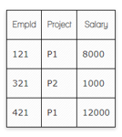

**Now take these two tables:**

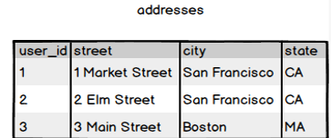

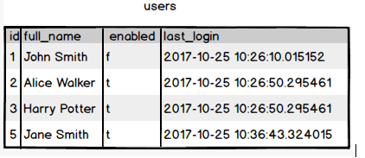

**Ques.11. Write a SQL query to fetch all users full_name from San Francisco.**

**Your Answer:**

SELECT full_name

FROM addresses

FULL JOIN users

ON addresses.user_id = users.id

WHERE city = ‘San Francisco’;

**Ques.12. Write a SQL query to fetch all users full_name, last_login who are enabled**

**Your Answer:**

SELECT full_name, last_login

FROM addresses

RIGHT JOIN users

ON addresses.user_id = users.id

WHERE enabled = ‘t’

**Ques.13. Write a SQL query to fetch all users full_name who are not from Main street**

**Your Answer:**

SELECT full_name

FROM addresses

FULL JOIN users

ON addresses.user_id = users.id

WHERE NOT addresses.street='Main Street';

**Ques.14. Write a SQL query to fetch all users full_name who are from Main street or San Francisco**

**Your Answer:**

SELECT full_name

FROM addresses

FULL JOIN users

ON addresses.user_id = users.id

WHERE addresses.street=’Main Street’ OR city=’San Francisco’;

**Ques.15. Write a SQL query to fetch user full_name who is equal to user_id from Boston (find user_id value in sub_query)**

**Your Answer:**

SELECT full_name

FROM users

WHERE id = (SELECT user_id

FROM addresses

WHERE city = ‘Boston’)